BROKERAGE
- UNLOCK INCOTERMS & MODE
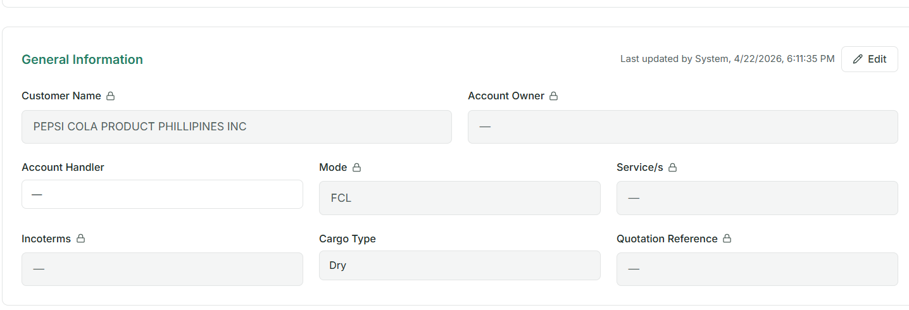
STATUSES
1. WAITING FOR ARRIVAL
2. ONGOING
3. DELIVERED
4. BILLED
5. PAID
6. AUDITED

- ADD “+” BUTTON FOR EXAMINATION TYPES FOR MORE TYPE
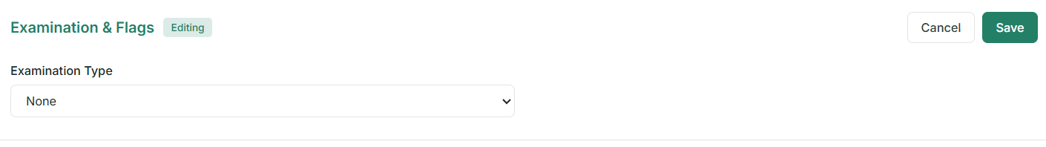

- PROFILING FOR CONSIGNEE, SHIPPER, CARRIER, FORWARDER, POD,

- Auto Complete (Automatic Suggestion)

- Create Input Fields (Manual Entry Section) for Duties & Taxes, Rate of Duty, Hs Code & Permits for database in shipment information.

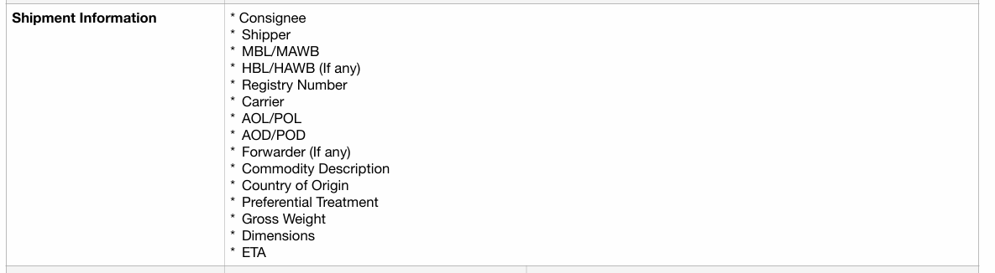

- SUB-CATEGORY IS REDUNDANT WITH LINE ITEMS
